we are

8A – Mrs. Arsenault (106)

[taylor.mcinnis-hicks@nbed.nb.ca](mailto:taylor.mcinnis-hicks@nbed.nb.ca)

8B – Ms. Willigar (105)

[janel.willigar@nbed.nb.ca](mailto:janel.willigar@nbed.nb.ca)

8C – Mrs. Furlotte (113)

[abigail.furlotte@nbed.nb.ca](mailto:abigail.furlotte@nbed.nb.ca)

8D – Mr. Lidstone (104)

[matthew.lidstone@nbed.nb.ca](mailto:matthew.lidstone@nbed.nb.ca)

8F – Ms. JardIne (107)

[serena.jardine@nbed.nb.ca](mailto:serena.jardine@nbed.nb.ca)

8G – MRs. Smith (117)

[lisa.smith@nbed.nb.ca](mailto:lisa.smith@nbed.nb.ca)

8I – Mme McGrath (108)

[gracia.mcgrath@nbed.nb.ca](mailto:gracia.mcgrath@nbed.nb.ca)

What we do best

**English**

Reading, writing, speaking, and listening are still paramount within the new holistic framework, but student choice will determine many of the ways in which these skills are developed and assessed. Materials are selected for student engagement based on relevance, authenticity, and inclusivity; text forms are above all else varied, highlighting the importance of student exposure to many modes of text. Long term, the goal is to create an environment in which literacy skills are instilled in all subject classrooms.

**French**

Lots of communication activities will be done this term in speaking, reading, and writing to help students discover who they are as language learners. We will be doing much of this through inquiry-based learning. It is encouraged that students read in French every night.

*Mr. Robichaud (124)

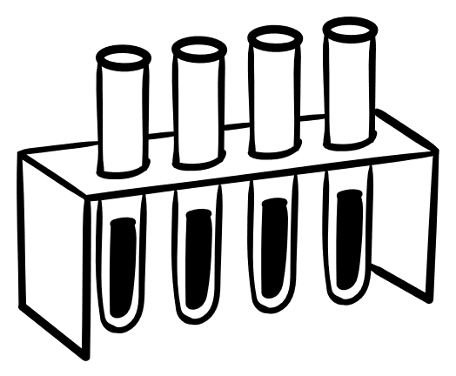**Science**

This term will focus on 'Beyond Earth-Human Presence in the Solar System.' All studies in science will be connected to the UN Sustainability goals. Students will use inquiry, investigation problems, find solutions, and create prototypes.

*Ms. Richard (102), Ms. Jardine (127), Mme Gallant (101)

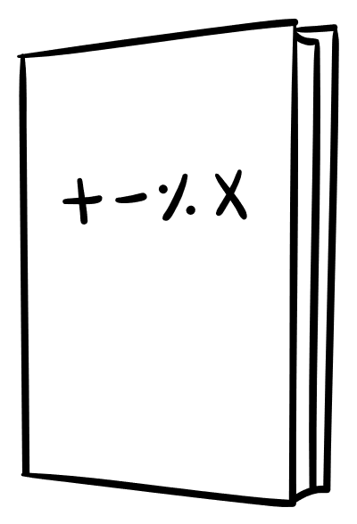**Math**

This term in math, we will be working on perfect squares and square roots, properties of circles, analyzing circle graphs, solving algebraic equations, finding percentages of numbers, multiplying integers, and applying the order of operations to whole numbers, decimals and fractions.

**Social Studies**

We are concentrating on empowerment. Students will explore history, geography, Wabanaki culture, economics and civics in the Atlantic region and around the globe.

*Ms. Richard (102), Ms. Jardine (127), Mme Gallant (101)

Homework?

**English**

* Read for one hour each week
* Write a quick write regularly from a list of suggested prompts**.**

**French**

* Recommended reading for 15 minutes each day

**Math**

* Practice times tables up to 15x15

**“The beautiful thing about learning is that no one can take it away from you.”** —B.B. King

Coming up this year

**Sports**

* Soccer
* Cheerleading
* Volleyball
* Basketball
* Badminton
* Cross Country
* Ultimate Frisbee*
* Track & Field*
* Softball*

*Tentative

**Clubs & Committees**

* Christmas Daddies
* Gardening Club
* Breakfast Club
* Dungeons and Dragons
* Leadership Council
* Quebec Trip
* Chess Club
* Recycling Club
* Other (Let us know!)

Welcome to Grade 8

Lewisville Middle School

Principal – Mr. Robert Bourque

Vice Principal – Mrs. Susan Carson

Vice Principal – Ms. Jillian Smith

School Phone Number - [(506) 856-3474](https://www.google.com/search?q=lewisville+middle+school&rlz=1C1GCEV_enCA997CA997&oq=lewi&aqs=chrome.0.69i59j69i57j46i433i512j0i131i433l2j46i131i433i512j0i131i433j0i433i512j46i131i433i512j0i131i433.1609j0j7&sourceid=chrome&ie=UTF-8)

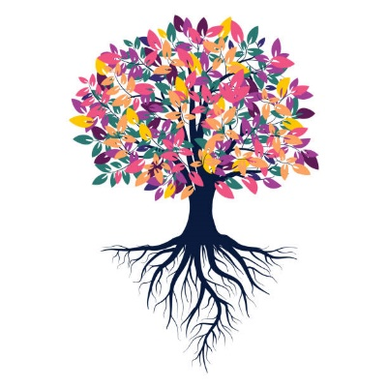

We’re Growing Successful learners!